Notes

*Interdependency of thermal losses with average tank temperature as a result of varied autarky means that there is actually an optimal autarky value.*

*It seems that based on the solar calculations and the heating demand of the excel model, the maximum autarky for a 900m2 115kWh/m2 House is actually only 17% at 0.1L/s- however I can set an autarky above this value so there must be an issue here.*

*The autarky is increased in my model as a result of lower thermal losses meaning that colder water is charged more by the solar energy, rather than only adding a little at a time.*

**I am however controlling the mass flow to the house to maintain a constant 25K temperature drop.**

**It would be interesting to set an upper limit on mass flow to the house (say 0.1 L/s) whereby this is what the mass flow is capped at. Then calculate an autarky after the fact.**

**I can also adjust my autarky value until the maximum observed mass flow to the house is 0.1L/s and cap it there.**

Heat Pump

minimum and maximum massflowrate for heat pump

20% of maximum (min)

max: work out for myself 0.01kg/s (36 l/hr)

air flow: for 12kW heat pump it is approx. 80m3/min, I have adapted this into kg/s and will scale it with the capacity based on 12kW.

System layout

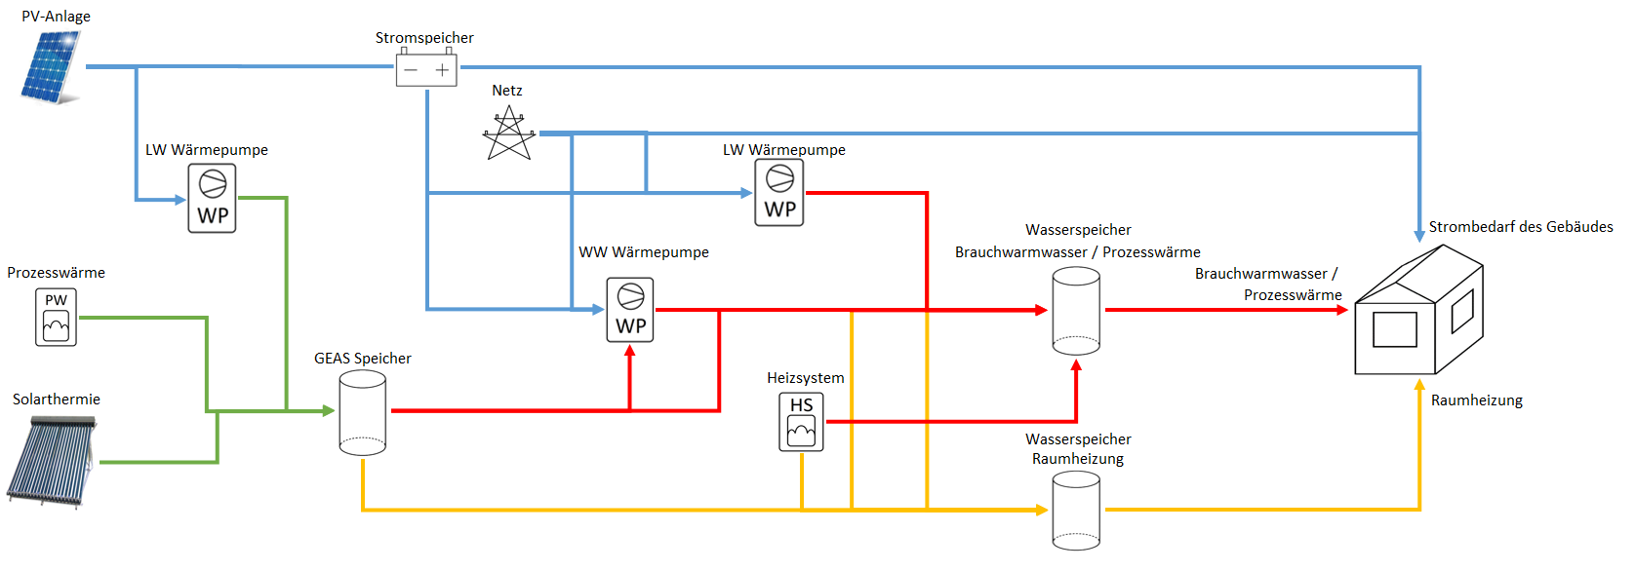

Should there be a buffer tank for the DHW production?